Project Design Phase - Solution Architecture
Date | 12 August 2026
Team ID | N/A
Author / Team Member | Ruturaj Misal
Project Name | ShopEZ Ecommerce Application
Maximum Marks | 4 Marks

Architectural Overview - Designer: Ruturaj Misal
ShopEZ employs a 3-tier Model-View-Controller (MVC) architecture ensuring strict separation of concerns, high maintainability, and horizontal scalability across Presentation, Application, and Persistence layers.
1. High-Level System Architecture Diagram:

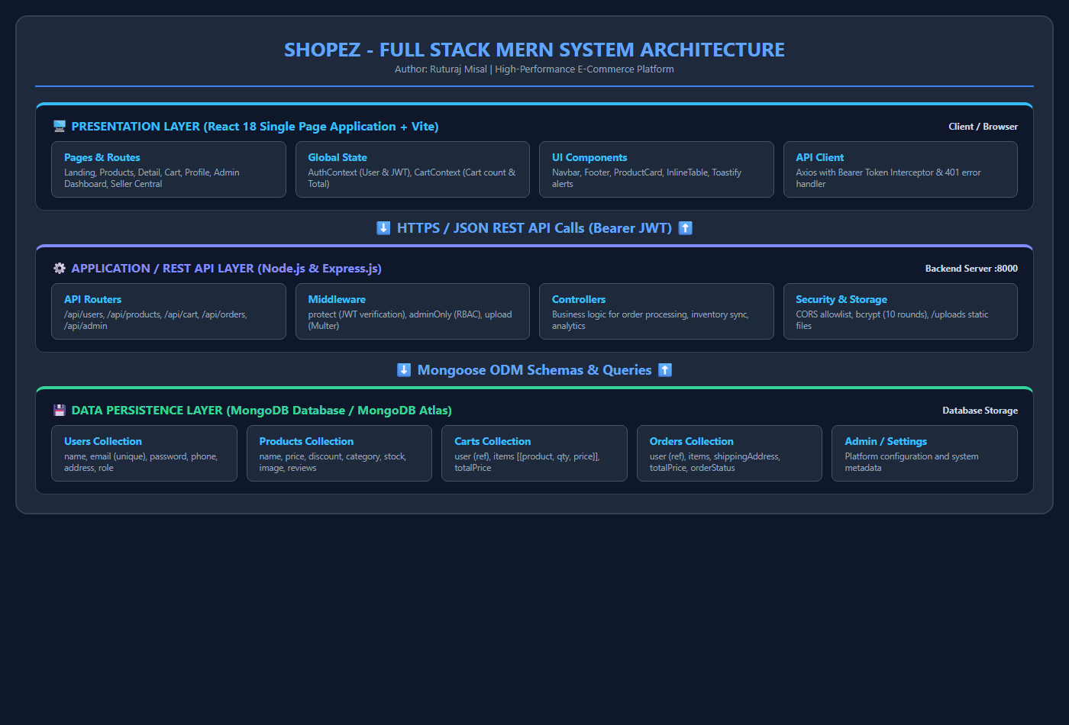
Figure 4: ShopEZ 3-Tier Full Stack MERN Architecture

2. Database Schema & Entity Relationship Diagram:

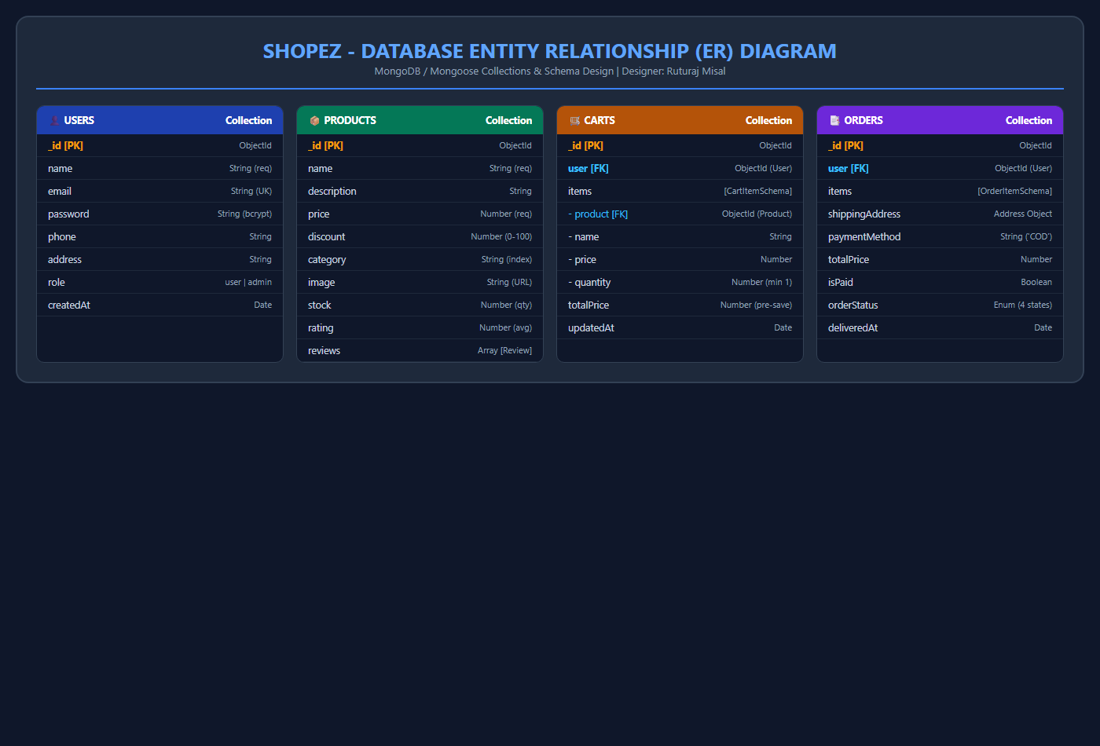
Figure 5: MongoDB Entity Relationship (ER) Schema for ShopEZ

Collection Name | Key Fields & Types | Relationships & Indexes | Business Purpose
Users | _id: ObjectId  name: String  email: String (unique)  password: String (hashed)  phone: String  address: String  role: String ('user'|'admin') | Referenced by Cart, Order, and Product reviews. Unique index on email. | Stores authenticated user profiles, shipping defaults, and authorization privileges.
Products | _id: ObjectId  name: String  description: String  price: Number  discount: Number  category: String  image: String  stock: Number  reviews: Array  rating: Number  numReviews: Number | Indexed by category and text search on name/description. Embedded reviews array. | Holds master merchandise inventory, pricing, discount percentages, and customer feedback.
Carts | _id: ObjectId  user: ObjectId (ref: User, unique)  items: [{product, name, price, image, quantity}]  totalPrice: Number | 1-to-1 relationship with User. Items reference Product ObjectId. | Persists user shopping bag with pre-save automated total price computation.
Orders | _id: ObjectId  user: ObjectId (ref: User)  items: [orderItemSchema]  shippingAddress: {address, city, state, zipCode, country}  paymentMethod: String  totalPrice: Number  isPaid: Boolean  orderStatus: 'Processing'|'Shipped'|'Delivered'|'Cancelled' | 1-to-many relationship from User. Historical snapshot of purchased items and prices. | Complete order audit trail from placement through delivery and settlement.

